Eventi
Use Case Specification

Submitted to:

Asst. Prof. Ma. Rowena C. Solamo
Faculty Member
Department of Computer Science
College of Engineering
University of the Philippines, Diliman

Submitted by:
Dimaano, Aaron Diego I.
Lopez, Matthew S.
Torres, Jacob Angelo V.

In partial fulfillment of academic requirements
for the course
CS 191 Software Engineering I
of the
1st Semester, AY 2015-2016
Unique Reference:
The documents are stored in https://github.com/Tom-2013-06417/CS191-192_Event_Sharing/tree/master/02-Requirements%20Engineering.
Link to this document:

Document Purpose:
The purpose of this document is to exhaust the step-by-step process of the Use Cases in every scenario possible. In this case, this document’s purpose is to show how the administrator would manage the existing accounts in the website and properly execute a plan of action in case of issues.

Target Audience:
To our project client and adviser, our fellow 191 classmates, and our future selves when they need to refer back to this document.

Revision Control:

Revision Date | Person Responsible | Version  Number | Modification
09/18/15 | Dimaano, Diego  Lopez, Matthew  Torres, Jacob | 1.0 | Initial Document

Use-Case Name: Manage accounts

Description: By controlling who stays within the site’s community, administrators can culture a healthy environment. This also provides an avenue for people who have forgotten or need help with their account credentials.

Preconditions: There is an internet connection to the Eventi server and a device with browsing capabilities.

Flow of Events:

Scenario Name | Description
Scenario 1 (Basic Flow)  Applicant is assigned to the training squad. | 1. Selection committee gets application form.  2. Club staff prepares try-out area.  3. Selection committee evaluates applicant's performance in mock try-outs.  4. If applicant needs training, he is assigned to the training squad.  5. Club staff keeps the application forms in the appropriate files.
Scenario 2  Applicant is assigned to the competing squad. | 1. Selection committee gets application form.  2. Club staff prepares try-out area.  3. Selection committee evaluates applicant's performance in mock try-outs.  4. If applicant plays excellent, he is assigned to the competing squad.  5. Club staff keeps the application forms in the appropriate files.

Activity Diagram of the Flow of Events:

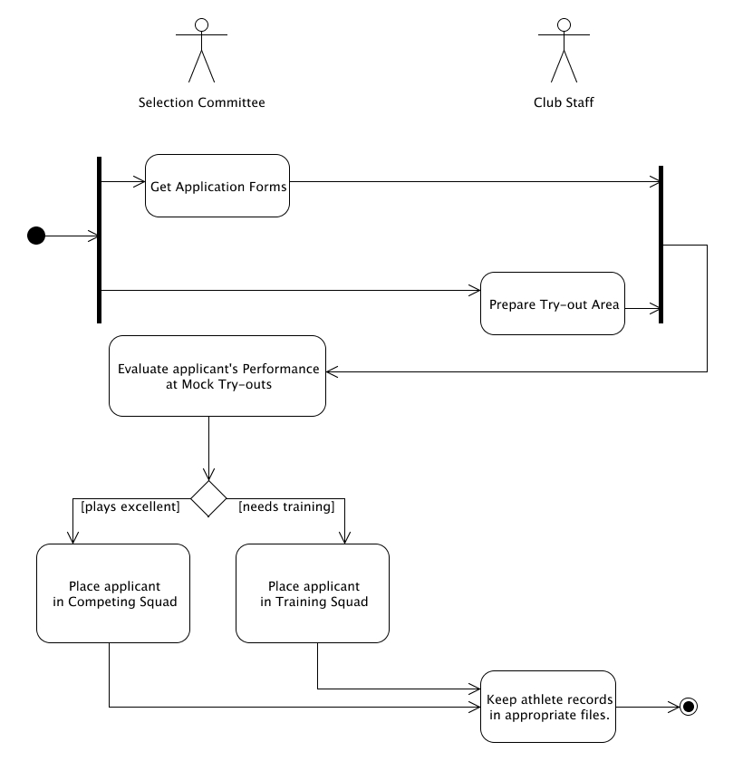

Post-conditions: Successful: The Eventi homepage has successfully loaded and the events are shown.
Failed: The website did not load.

Special Requirements: NONE

